Cosmos Episode 4 - Sky Full of Ghosts
As you watch the each of the videos, answer the following questions:
Cosmos Episode 4 - Sky Full of Ghosts
Questions | Notes
How has the speed of light and gravity impacted the universe?  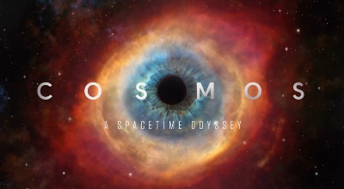 | 1. What does William Herschel mean when he tells his son there is a “sky full of ghosts”?  2. How fast does light travel in space?  3. Why do we see the Sun rise before it is over the horizon?  4. How far away is Neptune from the Earth (in light hours)?  5. How long would it take the Voyager Spacecraft to reach the nearest star in our galaxy?  6. Using the idea of how fast light travels, how do scientists know our universe is older than 6500 years?  7. How far away from Earth is the center of the Milky Way Galaxy?  8. How far away is the oldest galaxy we’ve ever discovered?  9. Why does no one know what happened before the Big Bang?  10. How long after the Big Bang did it take for stars to form?  11. Who discovered field forces that act on us even when we’re not touching other objects?  12. How fast do waves move through space, as calculated by James Maxwell?  13. Why did Einstein’s family move from Germany to Northern Italy?  14. What two things did the book Einstein read as a kid discuss on the first page?  15. What did Einstein call the “rules” that must be obeyed when traveling at high speeds?  16. What is the name of the man Neil deGrasse Tyson calls “one of the greatest scientists you’ve probably never heard of” and what did he discover?  17. What happened to the fire hydrant when it was exposed to 100,000g?  18. What is the name of the first black hole ever discovered and how did we “see” it?  19. Why does Neil deGrasse Tyson call black holes the “subway system of the Universe”?  20. If getting sucked into a black hole could cause an explosion similar to the Big Bang, what would be in the center of that black hole?  21. What type of “time travel” did John Herschel invent?
Summary (What is the BIG idea presented in the video):

